DBMS Lab Quiz

Tarun M

PES1UG20CS462

Roll – 57

Section - H

1. List the names of the Technical Analysts and total numbers of blood units processed by them in the ascending order of the number of blood units processed

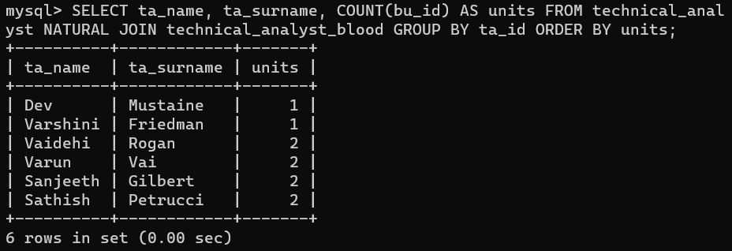

1. Write a query to display the number of donors and the number of requests for particular blood groups in the descending order of requests

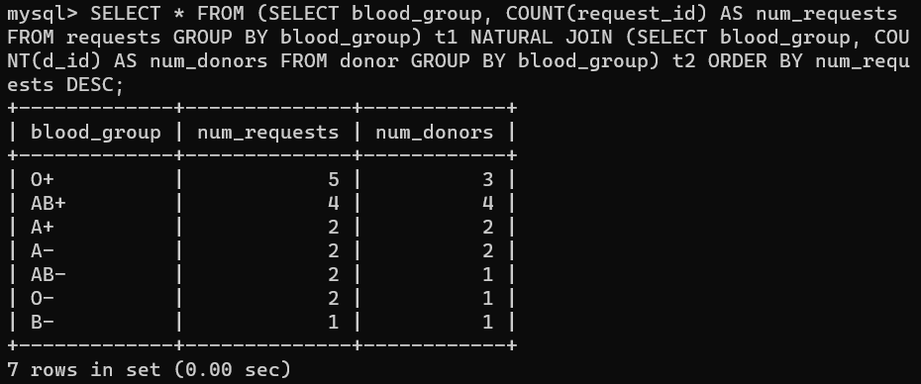

1. Write a trigger to prevent the addition of a new Blood Bank in the localities where a blood bank already exists as it requires ‘statutory permission’

